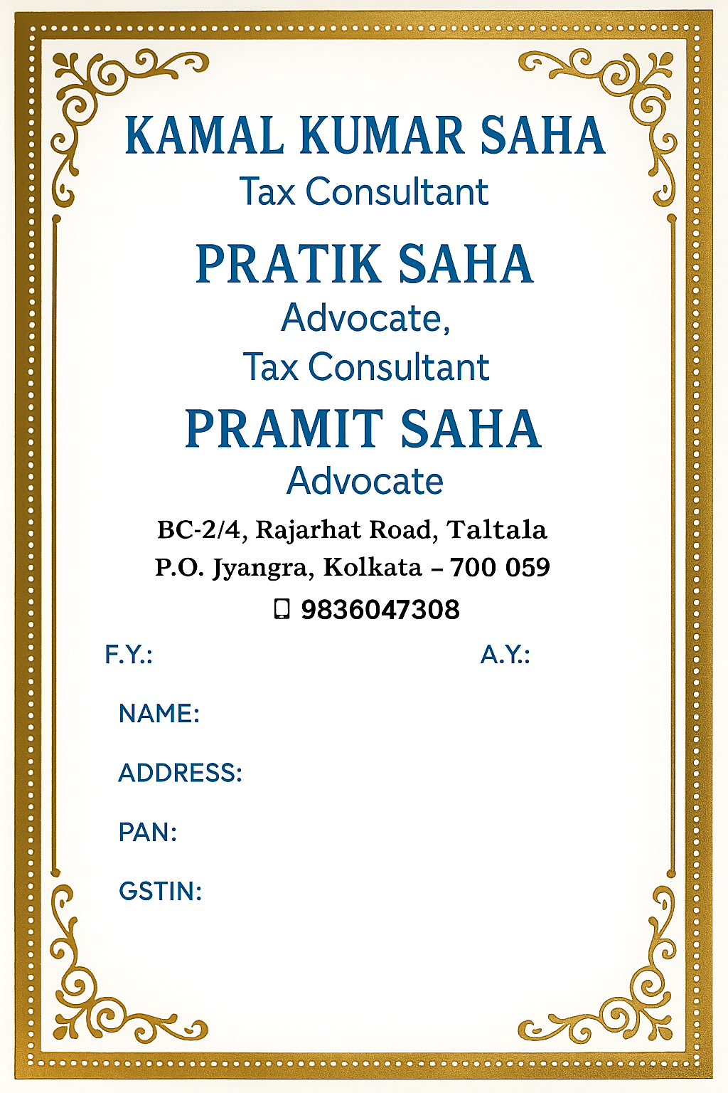

**2024 – 2025 2025 - 2026**

**Prasenjit Chakraborty**

**B-16, Rajarhat Road, Taltala, Kolkata - 59**

**ANXPC4204G**